

# Perth Modern School

### Semester Two Examination, 2018

### Question/Answer Booklet

# MATHEMATICS

**METHODS**

**UNIT 3 & 4**

## Section Two:

## Calculator-assumed

Student’s name

Your Teacher’s name

## Time allowed for this section

Reading time before commencing work: ten minutes

Working time for section: one hundred minutes

## Materials required/recommended for this section

***To be provided by the supervisor***

This Question/Answer Booklet

Formula Sheet (retained from Section One)

***To be provided by the candidate***

Standard items: pens (blue/black preferred), pencils (including coloured), sharpener, correction fluid/tape, eraser, ruler, highlighters

Special items: drawing instruments, templates, notes on two unfolded sheets of A4 paper, and up to three calculators approved for use in the WACE examinations

## Important note to candidates

No other items may be taken into the examination room. It is **your** responsibility to ensure that you do not have any unauthorised notes or other items of a non-personal nature in the examination room. If you have any unauthorised material with you, hand it to the supervisor **before** reading any further.

## Structure of this paper

|  |  |  |  |  |  |
| --- | --- | --- | --- | --- | --- |
| Section | Number of questions available | Number of questions to be answered | Working  time (minutes) | Marks available | Percentage of exam |
| Section One:  Calculator-free | 7 | 7 | 50 | 50 | 35 |
| Section Two:  Calculator-assumed | 13 | 13 | 100 | 103 | 65 |
|  | | | **Total** | 153 | 100 |

## Instructions to candidates

1. The rules for the conduct of examinations are detailed in the school handbook. Sitting this examination implies that you agree to abide by these rules.
2. Write your answers in this Question/Answer Booklet.
3. You must be careful to confine your response to the specific question asked and to follow any instructions that are specified to a particular question.
4. Spare pages are included at the end of this booklet. They can be used for planning your responses and/or as additional space if required to continue an answer.

* Planning: If you use the spare pages for planning, indicate this clearly at the top of the page.
* Continuing an answer: If you need to use the space to continue an answer, indicate in the original answer space where the answer is continued, i.e. give the page number. Fill in the number of the question that you are continuing to answer at the top of the page.

1. **Show all your working clearly**. Your working should be in sufficient detail to allow your answers to be checked readily and for marks to be awarded for reasoning. Incorrect answers given without supporting reasoning cannot be allocated any marks. For any question or part question worth more than two marks, valid working or justification is required to receive full marks. If you repeat any question, ensure that you cancel the answer you do not wish to have marked.
2. It is recommended that you **do not use pencil**, except in diagrams.
3. The Formula Sheet is **not** to be handed in with your Question/Answer Booklet.

Section Two: Calculator-assumed 65% (103 Marks)

This section has**thirteen (****13)** questions. Answer **all** questions. Write your answers in the spaces provided.

Working time for this section is 100 minutes.

Question 8 (11 marks)

The profit for the first few months of a company vary according to the function , where t represents months.

Hint: Use radians.

(a) FInd the first and second derivatives of the profit function and explain exactly

how these derivatives could help you graph the function. (6)

(b) Sketch the profit equation on the set of axes. (3)

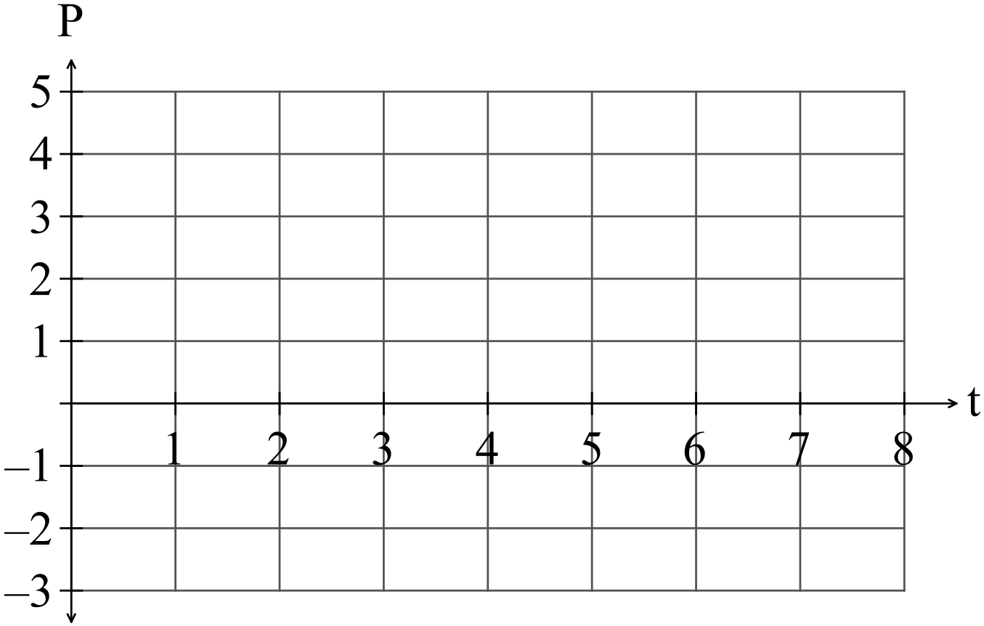

After the first two months when the profit had been increasing, the owner employed more staff and it took a little while for sales to start to increase again.

(c) Determine when the profit started to increase again. (1)

(d) Determine when the break even point was reached i.e. when profit again became non-negative. (1)

Question 9 (4 marks)

Eight red marbles and 12 yellow marbles are placed in a bag

and mixed thoroughly.

One marble is selected and its colour noted then it is replaced

in the bag and mixed thoroughly with the other marbles again.

This process is repeated a number of times.

(a) What is the probability that the first yellow marble drawn is the fourth? (2)

A marble can be drawn up to four times. The draw stops once a yellow marble is

selected.

(b) What is the probability that a yellow marble is not drawn? (2)

Question 10 (7 marks)

In 1880, the population in the United States was 50 189 209.

In 1930, the population had increased to 123 202 624.

(a) Taking  in 1880, set up an equation in the form  that can be used to estimate the population in the United Stated during the 50 year period. (2)

(b) Write down the average annual population growth over that period. (1)

Over the next 60 years to 1990, the population grew from 123 202 624 to 248 709 873.

(c) Determine if the rate of growth during the 60 years from 1930 to 1990 is the same as the rate of growth from 1880 to 1930. (1)

(d) Use the data from 1930 to 1990 to predict the population in 2016. (1)

NB. The actual population in 2016 was 324 118 787.

Question 11 (10 marks)

(a) (i) Find the expected value and variance of the probability density function in

the table below. (5)

|  |  |  |  |  |
| --- | --- | --- | --- | --- |
| *x* | 1 | 2 | 3 | 4 |
| *P*(*X = x*) | 0.3 | 0.2 | 0.2 | 0.3 |

(ii) The values of setare transformed so that 

Write down the expected value and variance of set  (2)

(b) Remy bet on the outcome of a spinner with probabilities as in the table

below.

|  |  |  |  |  |
| --- | --- | --- | --- | --- |
| *x* | 1 | 2 | 3 | 4 |
| *P*(*X = x*) | 0.3 | 0.2 | 0.2 | 0.3 |

It costs Remy $1 per spin and the payout is $2 for a 2 or a 3 and nothing

otherwise.

What is Remy’s average payout? (3)

Question 12 (6 marks)

The speeds of 250 vehicles, on a section of freeway undergoing roadworks with a speed limit of 60 kmh-1, had a mean and standard deviation of 56.9 kmh-1 and 3.6 kmh-1 respectively. A summary of the data is shown in the table below.

|  |  |  |  |  |  |
| --- | --- | --- | --- | --- | --- |
| Speed ( kmh-1) |  |  |  |  |  |
| Relative frequency | 0.024 | 0.272 | 0.504 | 0.188 | 0.012 |

(a) Use the table of relative frequencies to estimate the probability that the next vehicle to pass the roadworks

(i) was not exceeding the speed limit. (1 mark)

(ii) had a speed of less than 65 kmh-1, given they were exceeding the speed limit.

(1 mark)

(b) Subsequent tests on the measuring equipment discovered that it had been wrongly calibrated. The correct speed of each vehicle, $v$, could be calculated from the measured speed, $x$, by increasing $x$ by 6% and then adding 1.7.

(i) Calculate the adjusted mean and standard deviation of the vehicle speeds.

(2 marks)

(ii) Determine the correct proportion of vehicles that were speeding. (2 marks)

Question 13 (6 marks)

1. A lottery sells 1000 tickets and claims that there will be 10 winners. How many tickets should you buy so that you have a 20% chance of winning at least 1 prize. (3 marks)
2. Given the same p value from part a, Find a 95% confidence interval for a binomial distribution with n = 40, variance = 8

(3 Marks)

Question 14 (9 marks)

The simulation of a loaded (unfair) spinner is spun 60 times and the results recorded with the following results. (Below diagram is for illustrative purposes only)

|  |  |
| --- | --- |
| **Result** | **Count** |
| 1 | 5 |
| 2 | 20 |
| 3 | 15 |
| 4 | 15 |
| 5 | 5 |

(a) Calculate the proportion of even numbers recorded in this simulation. (2 mark)

(b) Determine the mean and standard deviation for the sample proportion of even numbers in 60 tosses, using the results above. (2 marks)

(c) It has been decided to create a confidence interval for the proportion of even numbers using the simulation results. The level of confidence will be chosen from 90% or 95%. Explain which level of confidence will give the smallest margin error. State the margin of error.

This simulation of 60 spins of the spinner is performed another 200 times, with the proportion of even numbers recorded each time and graphed.

(d) Comment briefly on the key features of this graph



Question 15 (8 marks)

From a random sample of $n$ people, it was found that 54 of them subscribe to a video streaming service. A symmetric confidence interval for the true population proportion who subscribe is $0.1842<p<0.2958$.

(a) Determine the value of $n$, by first finding the mid-point of the interval. (3 marks)

(b) Determine the confidence level of the interval. (4 marks)

Question 16 (8 marks)

The moment magnitude scale $M_{w}$ is used by seismologists to measure the size of earthquakes in terms of the energy released. It was developed to succeed the 1930's-era Richter magnitude scale.

The moment magnitude has no units and is defined as $M_{w}=\frac{2}{3}\log_{10}\left(M_{0}\right)-10.7$, where $M_{0}$ is the total amount of energy that is transformed during an earthquake, measured in dyn $∙$ cm.

(a) On 3 Sept 2018, an estimated $2.82×{10}^{21}$ dyn∙cm of energy was transformed during an earthquake near Albany, WA. Calculate the moment magnitude for this earthquake.

(1 mark)

(b) A few days later, on 8 Sept 2018, there was another earthquake with moment magnitude 5.2 just north of Denmark, WA. Calculate how much energy was transformed during this earthquake. (2 marks)

(c) Show that an increase of 2 on the moment magnitude scale corresponds to the transformation of 1000 times more energy during an earthquake. (4 marks)

Question 17 (8 marks)

A particle, initially stationary and at the origin, moves subject to an acceleration, ms-2, as shown in the graph below for $0≤t≤20$ seconds.

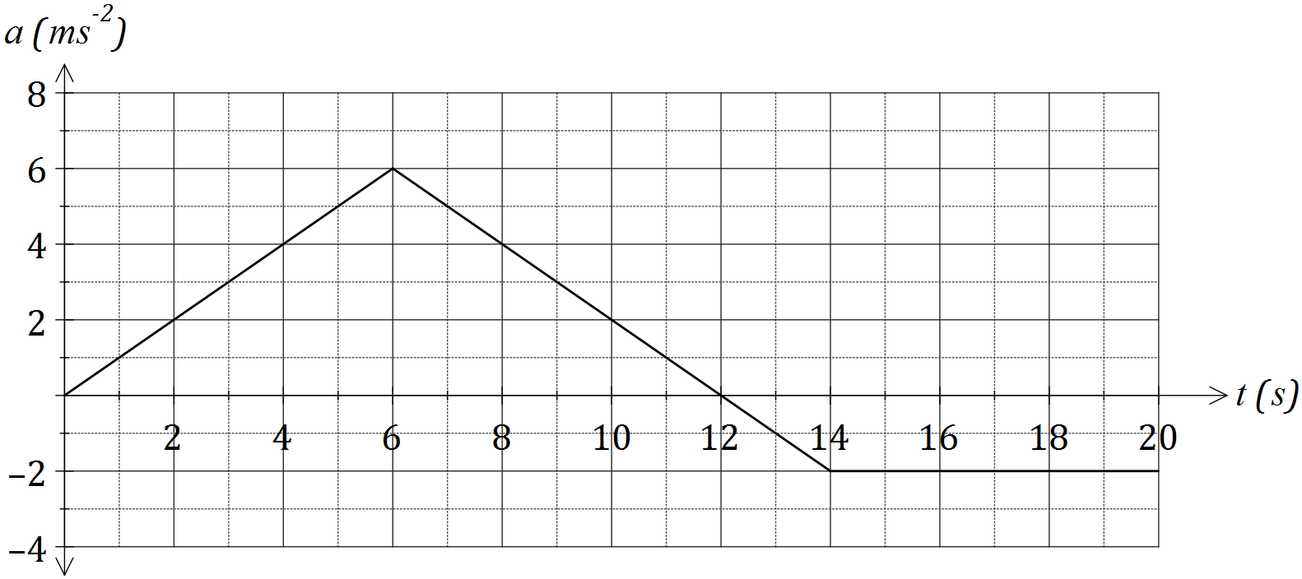

(a) Determine the velocity of the object when

(i) $t=6$. (1 mark)

(ii) $t=20$. (2 marks)

(b) At what time is the velocity of the body a maximum, and what is the maximum velocity?

(2 marks)

(c) Determine the distance of the particle from the origin after $3$ seconds. (3 marks)

Question 18 (11 marks)

Cans of soda water are advertised as containing 375 mL. However there have been complaints for one particular brand that several cans contained less than 375 mL causing the manufacturer to investigate the settings on the machines that fill the cans. It turns out that the amount the machines are filling the cans with follows a normal distribution with a mean of 377 mL and a standard deviation of 3 mL.

1. What percentage of cans contain less than the advertised quantity? (2 marks)
2. If 10 cans are chosen at random, what is the probability that at least half of them have less than the advertised quantity? (2 marks)
3. A random sample of 10 cans is selected and the quantity in each can is measured. What is the probability that the sample mean of the measurements is: (3 marks)
4. More than the advertised amount
5. Equal to the advertised quantity when rounded to the nearest mL

The manufacturer knows sufficient statistics to realise that if the machines are set to fill the same average amount, the exact amount in each can is more consistent (i.e. the standard deviation is smaller) there will be less chance of cans being under filled.

1. Given no change in mean, what is the standard deviation (correct to 2 dp) that would result in at most 10 in a 1000 cans being underfilled. Show all working and give your answer accurate to 2 dp. (4 marks)

Question 19 (8 marks)

Bruce is employed by Stark Industries as a geologist and is in charge of choosing between two of its sites for the construction of an open-pit mine. One of the sites will be sold to pay for the construction of the open-pit mine.

Bruce is examining samples from a recent drilling program for both sites to help with his decision. A sample taken from the first site has a mean sample grade of 4.6 g/t with a standard deviation of 0.56 g/t. Bruce found that the data for the samples are normally distributed.

(a) Determine the probability that a randomly chosen sample contains a

grade that is: (2 marks)

(i) exactly 4.6 g/t.

(ii) greater than 3.5 g/t.

(b) Determine the median score. (1 mark)

(c) The probability that another sample contained less than the particular

grade was 0.25 or 25%. Determine the maximum grade for the sample. (1 mark)

The set of samples obtained from the second potential site has a mean sample

grade of 4.7 g/t. The data was given to Bruce as a box-plot with the median of 4.72 g/t, the lower quartile of 4.2 g/t and the upper quartile of 5.2 g/t.

(d) Examine the above statistics to determine if the data for the second

potential site could be represented by a normal distribution.

Justify your conclusion. (2 marks)

(e) Which of the mine sites should be sold? Use your knowledge of statistics

and probability to support your choice. (2 marks)

Question 20 (7 marks)

(a) Use your calculator to find the area enclosed between the two functions

 and  as shown in the diagram below.

The points of intersection are shown.

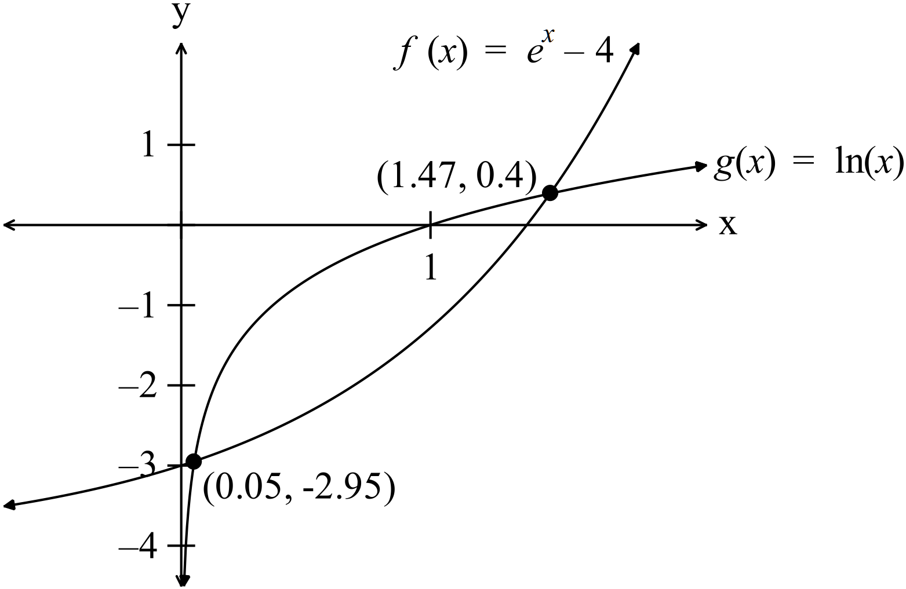 (3)

(b) A small colony of possums live in bushland on the near Margeret River.

The population of this colony was studied in 2018.

The population can be modelled by the equation  whereis in

years starting in 2018.

(i) What was the population in 2018? (2)

(ii) In what year will the population reach 100? (2)

Additional working space

Question number: _________

Additional working space

Question number: _________